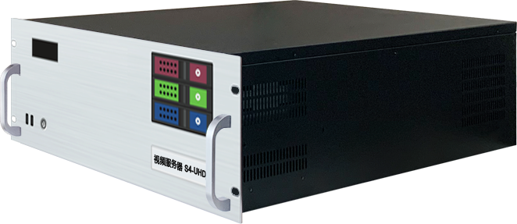
S4-UHD

Specification Document
Video Playback Control Server
S4-UHD video server is a multimedia integrated broadcast control server for large-scale LED broadcast control scenarios such as multimedia exhibition halls, banquet halls, and live performances. It has the signal processing capability of traditional multi-picture splicing processor, and integrates the media editing function of professional stage performance and the lighting arrangement control function. It can not only achieve high quality and ultra-high resolution point-to-point display, but also achieve a variety of display creativity. S4-UHD video server with professional LED broadcast control software, to provide users with convenient scene management and professional LED human-computer interface, suitable for performing arts, exhibitions, large buildings and a variety of creative display application scenarios.

Functional features:
1. Support four DP outputs;
2. Support multi-screen splicing;
3. Support video hardware decoding;
4. Support expansion of external signal acquisition, SDI/DVI/HDMI/CVBS, etc.
5. Program editing in timeline mode;
6. Support custom resolution;
7. Support tablet central control playback;
8. Support TCP/UDP network commands;
9. Support screen rotation at any Angle, suitable for a variety of creative display applications;
10.LTC time code synchronization;
11. Support 3D mapping;
12.Built-in universal decoder, can decode HAP, DXV, HEVC and other common and professional video formats.

System introduction:
LED broadcast control system (window version)
LED broadcast control system (window version) is a powerful media broadcast control system, supporting audio and video media, capture card, NDI, pictures, WEB, subtitles, PPT and other broadcast control needs, support TCP/UDP protocol network control commands, provide the docking protocol, can be seamlessly connected with the central control system control.
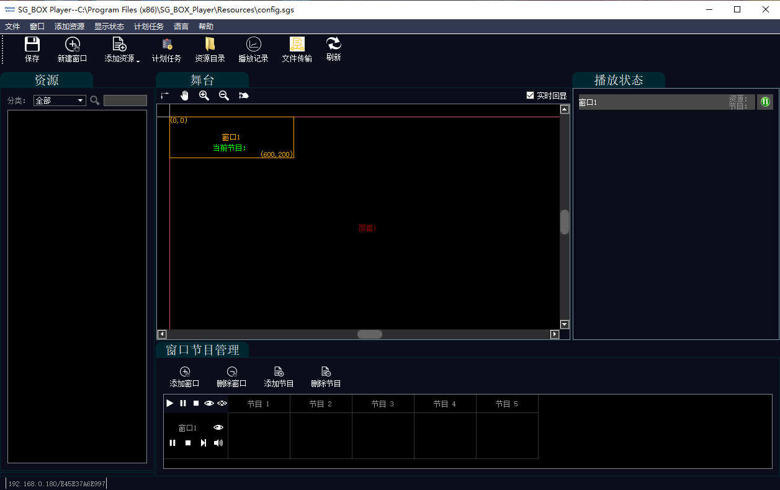
LED broadcast control system (window version) features
- Ultra HD output
Single machine supports up to 10K×2K output load, and supports ultra-high resolution video decoding, which can easily complete ultra-high resolution point-to-point display.
- Universal decoding
Built-in powerful universal decoder, support almost all video formats;
- Playrecord query
Query playback records, including playback duration and times.

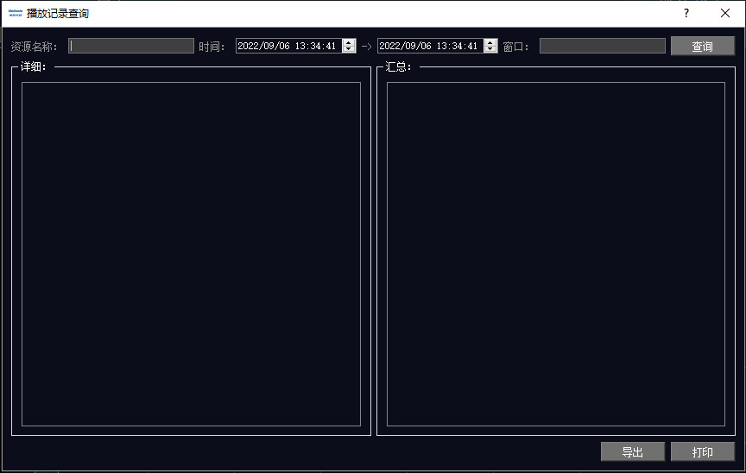
NDI network collection
LED broadcast control system (window version) supports NDI network acquisition, extremely low latency, high-definition picture quality and the platform characteristics of Windows/macOS make screen acquisition more convenient.

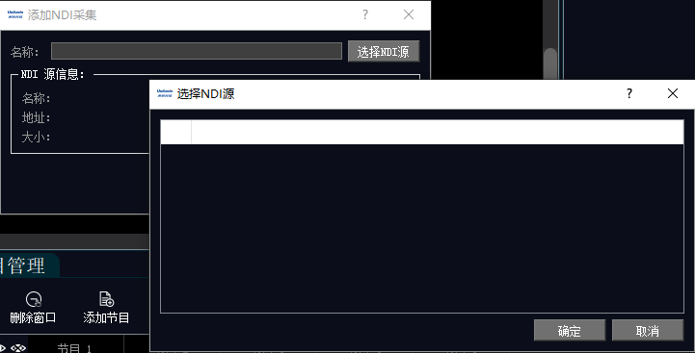

Support acquisition card
Can achieve PPT/ camera capture screen try to capture and output
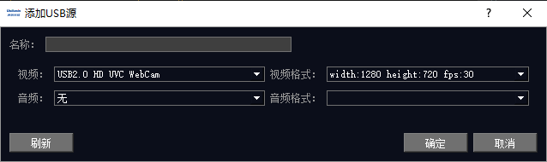

Planned task
It can customize the window version playback, program playback and other tasks at specific times in the future to achieve weekly fixed cycle time Xie Huan program content playback.

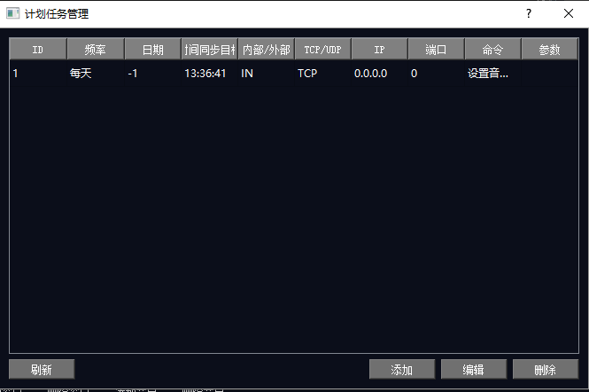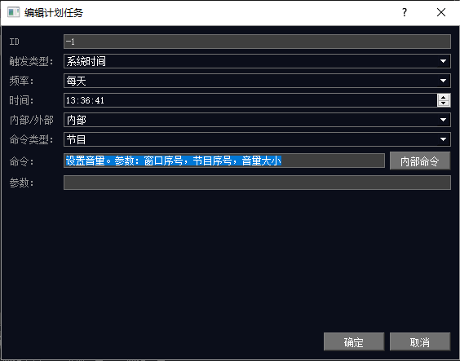

Flying screen interactive system
The system can quickly send the material on the interface of the control device to the screen of the display device, and can control the content on the screen of any one or more display devices on one or more control devices. Can preset multiple display device screen parameters and public material library. The core of the system is deployed on the Web server, and both the fly screen control terminal and the large screen display terminal run based on the browser, which has good cross-platform compatibility. It can be operated remotely and managed easily.

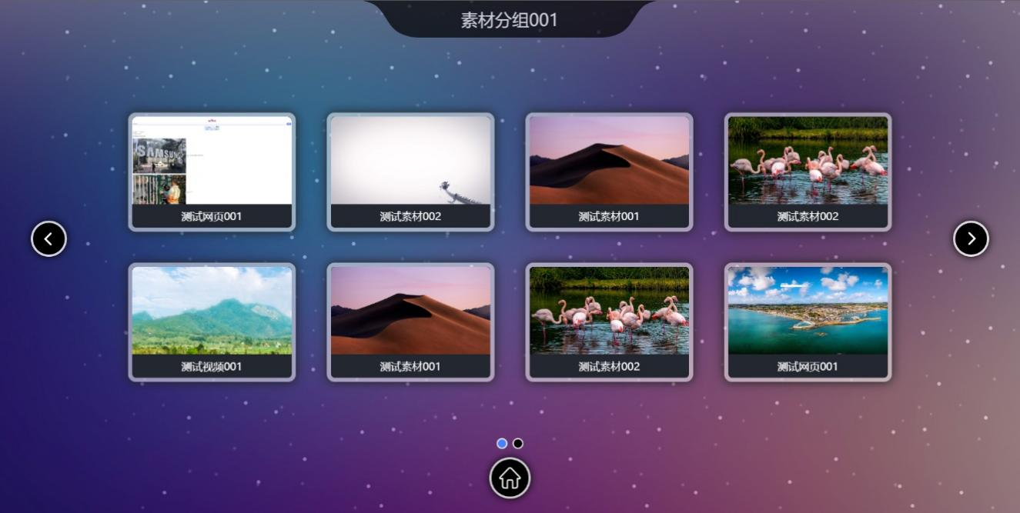

Global total control system
The global control system is a set of multi-scene integrated management system, including remote desktop, full link monitoring, central control command, program material management, video transcoding, gesture central control and other functions.

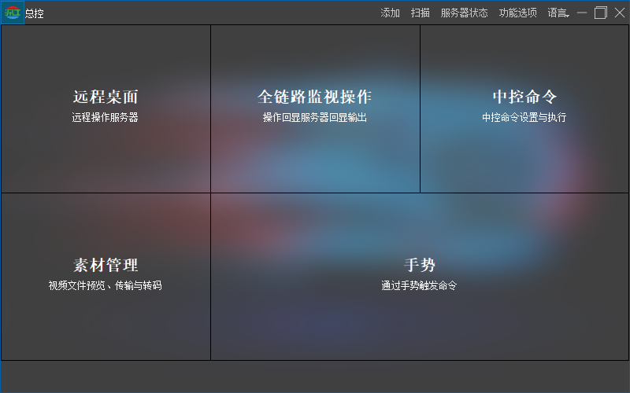
Software main page
Remote desktop:
Remote desktop support centralized control of computer hosts in the LAN, one-click connection batch management.
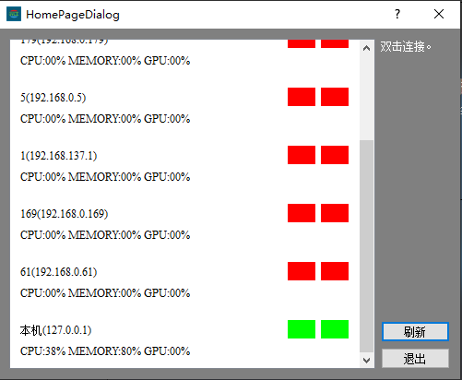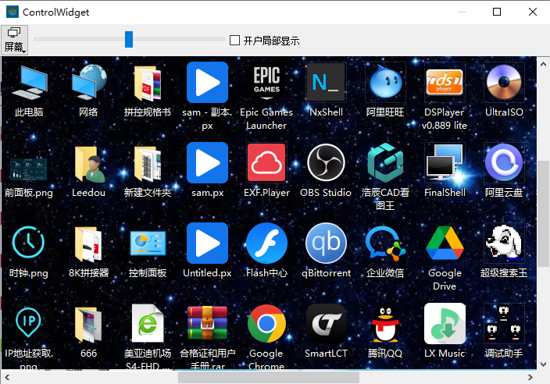
Full link monitoring:
The full link monitoring system can project the desktop screen of any computer in the LAN to the large-screen centralized display preview.

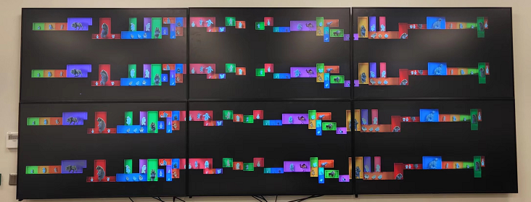

Central control system:
Central command supports TCP/UDP/RS232/485 protocol command transmission, can control any device that supports central command, such as PLC, smart curtains, projectors and various broadcast control software that supports network command.
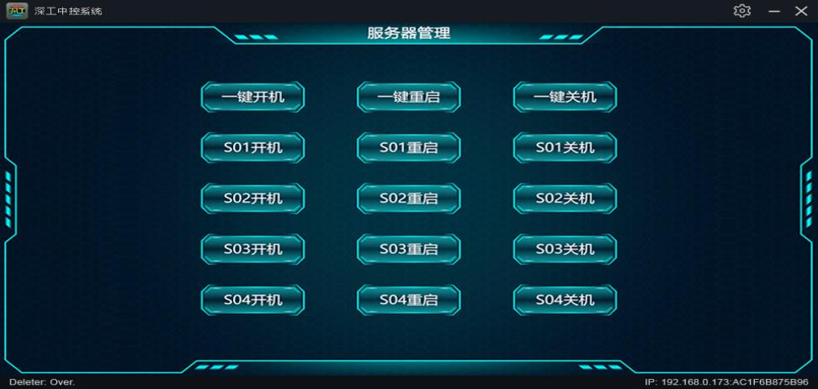
Material Management:
It can centrally manage video files in the computer, and support batch preview, batch transcoding, and delivery to the specified server computer.
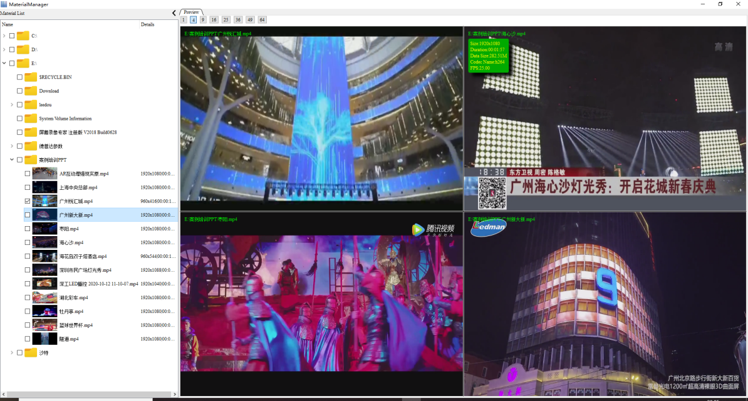

Gesture commands and status monitoring:
Network commands can be started through gestures, which are used to achieve effects such as taking photos.
Real-time monitoring of LAN computer status, support remote wake up or shutdown operation.

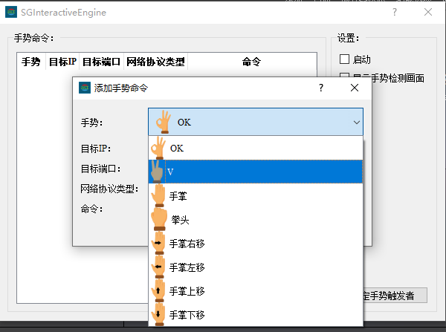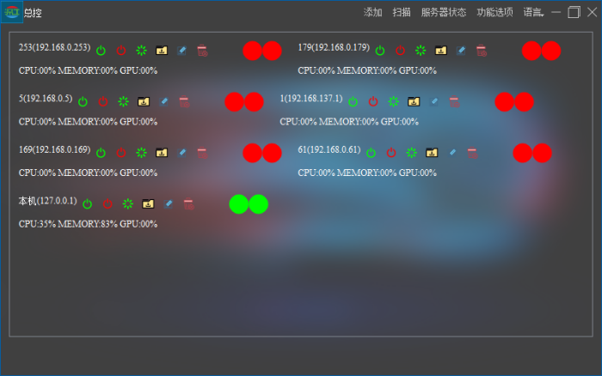

Interactive game
3D parkour motion interactive game
Users can experience parkour through this interactive game. Users can control the characters in the three-dimensional scene by running, jumping and other physical actions, and feel the exciting and exciting racing atmosphere.
Application scenario: commercial entertainment, exhibition hall

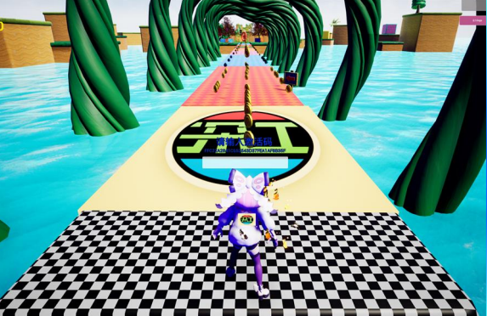

Aircraft motion interactive game
Users can experience the feeling of flying fast through the air through this interactive game. The user can control the lifting and landing of the aircraft (aircraft, spacecraft) and the flight direction by moving the direction of the body, and can fly freely in the scene and avoid obstacles.
Application scenario: commercial entertainment, exhibition hall

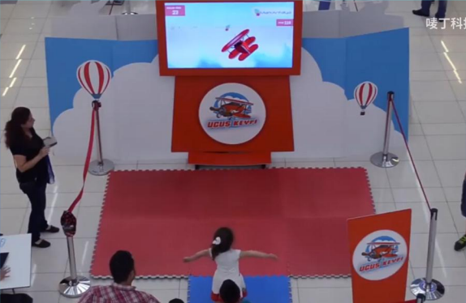

Simulation shooting motion-sensing interactive game
Users can experience the feeling of fast shooting through the motion-sensing interactive game. The user can control the direction of the left and right movement of the character by moving the body, control the gun shooting with gestures, switch weapons with hands, the enemy disappears after the bullet hits the enemy, and randomly drop the reward.
Application scenario: commercial entertainment, exhibition hall

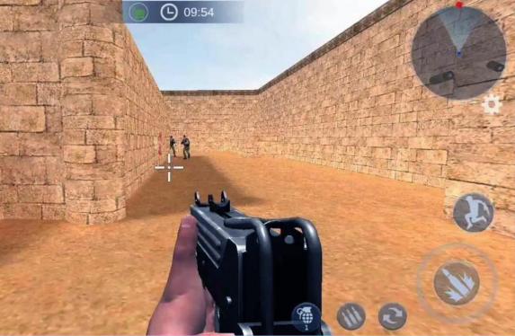

3D spherical interactive game
The rolling direction of the ball can be controlled by the direction of the user's body movement. The rolling ball can roll rapidly in the scene, and the climbing and jumping rolling ball can impact other objects in the scene, and the hit object can simulate the real collision effect.
Application scenario: exhibition hall, commercial entertainment

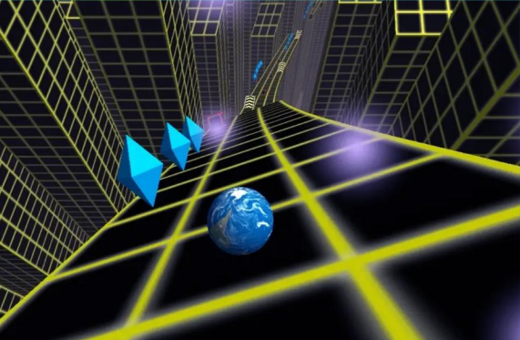
Cut fruit body sense interactive game
Users control the cutting system on the screen with their hands, waving their hands can make cutting effects, and touching the moving fruit can be chopped and has a points function.
Application scenario: exhibition hall, commercial entertainment
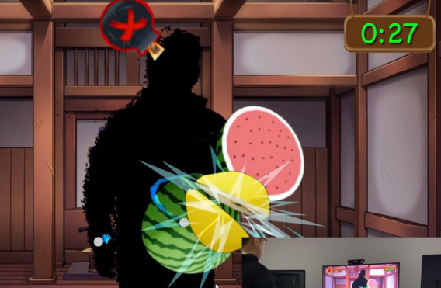

Silhouette motion interactive game
When the user passes through the induction area, the background theme (water, digital, particles, photoelectric, etc.) can be brushed with the shadow, and the background picture and theme can be changed and specified.
Application scenario: exhibition hall, commercial entertainment

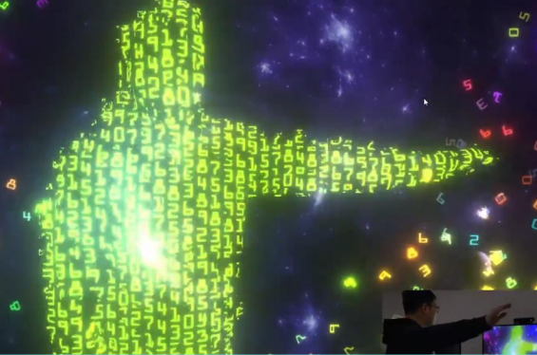
Specifications：
Model No. | S4-UHD
System connection
Output channels： | 4-way 4096*2160@60Hz Support for customization, through the DP1.2 cable compatible with all categories of master or send card
Video input： | Default none (optional 4K/2K input, additional fee required)
Input channels： | Default none (Optional 1-4 HDMI/DVI/SDI, additional fee required)
Hardware parameter | Hardware parameter
CPU： | Intel Xeon W-2155@ 3.00GHz 10 cores, 20 threads, turbo frequency up to 4.5GHz
Memory： | 32GB DDR4 RECC
Storage： | 1TB M.2 interface SSD, hot swappable hard drive can be added
Graphics card： | NVIDIA RTX A4000 16GB Professional graphics card  NVIDIA T400 Control graphics card
Capture card： | Default none (Optional to support HDMI/DVI/SDI multiple signal input 2K/4K custom capture card)
Power： | The Great Wall G6 650W
Computer case： | 4U Hot swap chassis
Radiator： | Water cooling (CPU), Air cooling (GPU)
Software | Software
Operating system： | Windows 10 Enterprise Edition
Broadcast control system： | Window version broadcast control system
Interface | Interface
Output： | 4 DP1.2, the signal can be converted to HDMI, DVI output through the active DP adapter cable.
video： | 1 standard 3.5mm audio output interface; 1 standard 3.5mm audio input interface
HDMI/DVI | 1 HDMI port; 1 DVI port (for connecting control display)
COM | 1 COM interface
USB： | 2 front-facing USB3.0; 4 rear USB3.0
Network： | 2 RJ45 network ports
Power | Power
Input power： | 110-220V Alternating current ~ 50hz
Maximum power： | 650W
Physical parameter | Physical parameter
Installation system： | 4U Rack-mounted installation
Equipment size： | 482mm(w)*178mm(H)*580mm(D)
Working environment： | temperature：5-35°C（40°-95°F），humid：5％-95％（non-condensing）

Functional
Media support | Support PPT, web pages, videos, pictures, audio and other media playback
Slice mask | Supports the import of slice data and mask function
3DWEB Broatcast control System | Supports multi-terminal control
Flying screen system | Support one-to-many
Central control System (Standard Edition) | Support
The monitoring system is displayed | Support
Interactive game | Support
NDI Capture | Support
Streaming media playback | Support
LTC/NTC Time code | Supports receiving and sending time codes
DMX512 | Support recording playback and broadcast control by DMX512 signal control
TCP/UDP protocol | Supports sending TCP/UDP control commands and receiving TCP/UDP control commands

Appearance Size：
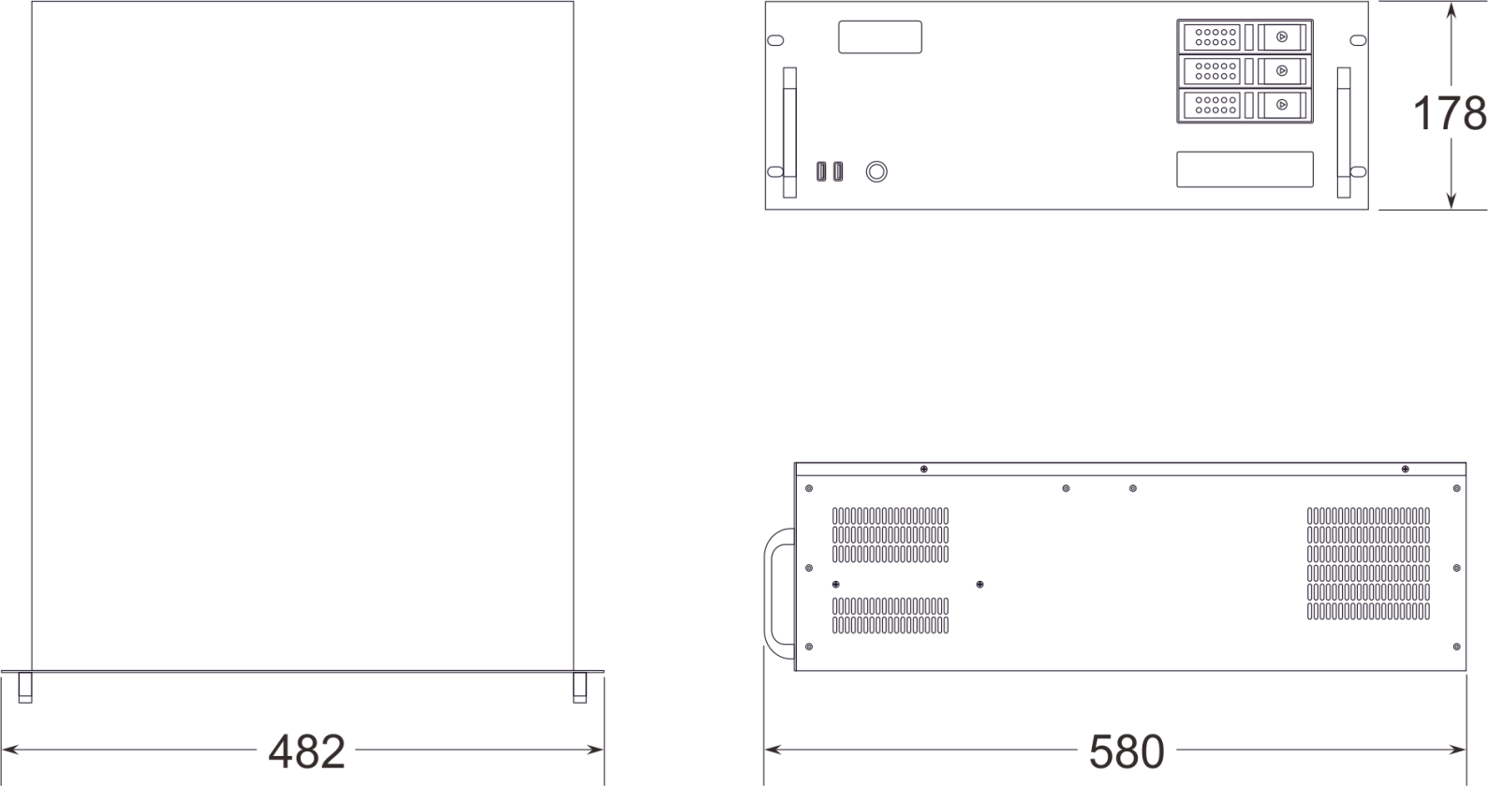

Appearance interface：
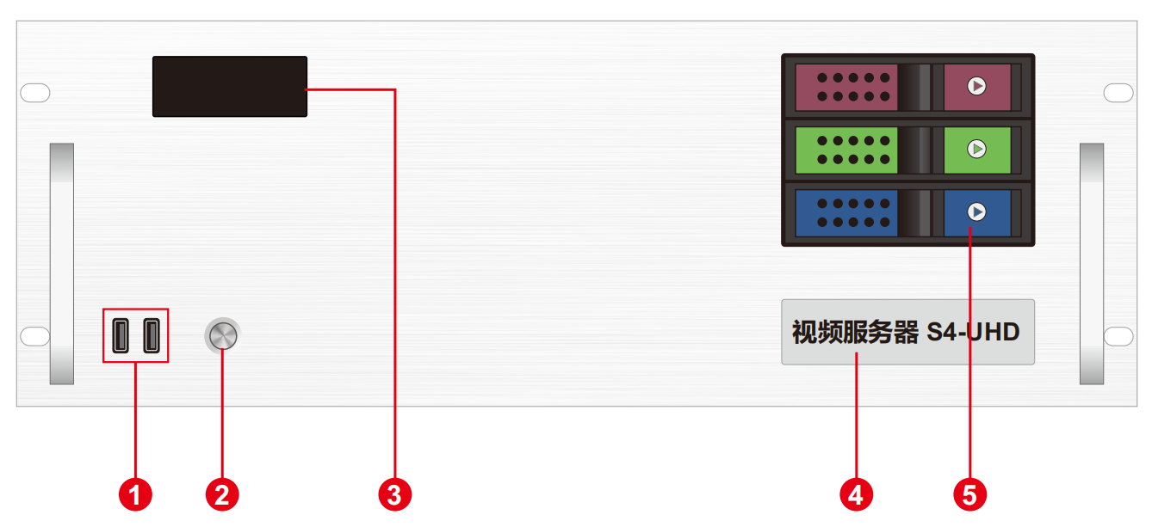

（FRONT）
Index | Interface | Number | Description
1 | USB | 1 | • Type-A USB3.0×2  • Connectable to mouse and keyboard.
2 | Power switch button | 1 | • Button for power switch.
3 | Temperature control display screen | 1 | • Display server runtime, temperature, cooling fan status, and abnormal alarms.
4 | Label | 1 | • Server model and name identification.
5 | Front-mounted hard drive enclosure | 3 | • Supports installation of 3.5-inch and 2.5-inch SATA interface hard drives.

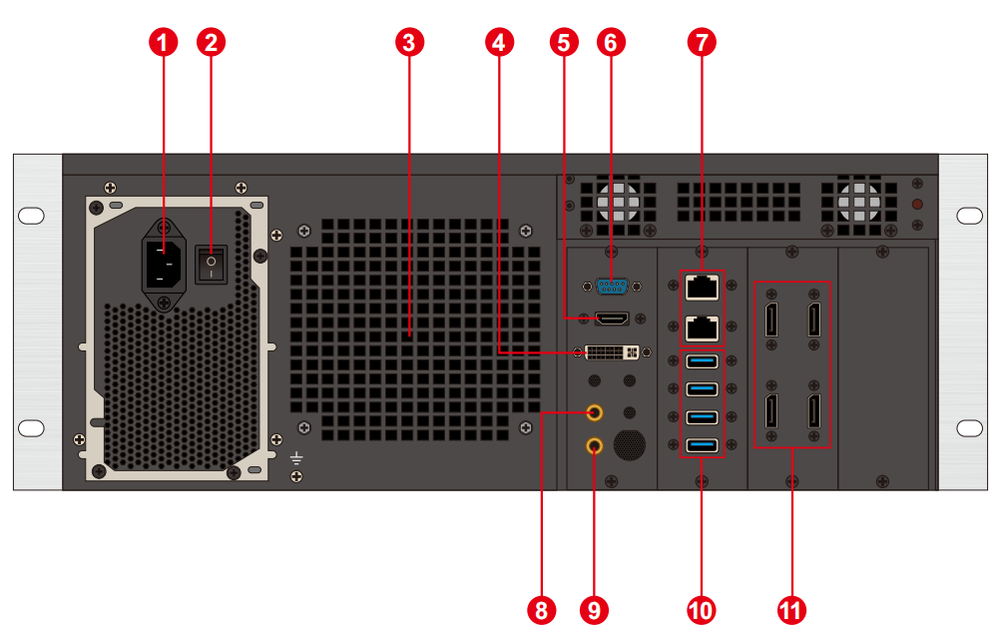

（BACK）
No. | Interface description | No. | Interface description
1 | Power input | 7 | Network interface
2 | AC switch | 8 | 3.5㎜Audio output
3 | Heat sink | 9 | Microphone input
4 | DVI Output | 10 | USB3.0
5 | HDMI Interface | 11 | DP Output
6 | COM Interface

Order type：
S4-UHD

Packing list：
NAME | NUMBER | SPECS | UNIT
Host | 1 | S4-UHD
Power cord | 1 | 1.8 m
HDMI Cable | 1 | 2 m
DP Cable | 4 | 2 m
Wireless network card | 1 | USB Wireless network card
Keyboard and mouse | 1 | Shuang Yanfei USB keyboard and mouse
Certificate of conformity | 1
inspection report | 1
Functional checklist | 1
Packing list | 1

